1. Using the following function (which was downloaded with the data set), plot all intervals. What proportion of your confidence intervals include the true population mean? Is this proportion exactly equal to the confidence level? If not, explain why.

**plot_ci**(lower_vector, upper_vector, **mean**(population))

|  |
| --- |
| download.file("http://www.openintro.org/stat/data/ames.RData", destfile = "ames.RData")  load("ames.RData")  population <- ames$Gr.Liv.Area  samp_mean <- rep(NA, 50)  samp_sd <- rep(NA, 50)  n <- 60  for(i in 1:50){  samp <- sample(population, n) # obtain a sample of size n = 60 from the population  samp_mean[i] <- mean(samp) # save sample mean in ith element of samp_mean  samp_sd[i] <- sd(samp) # save sample sd in ith element of samp_sd  }  lower_vector <- samp_mean - 1.96 * samp_sd / sqrt(n)  upper_vector <- samp_mean + 1.96 * samp_sd / sqrt(n)  c(lower_vector[1], upper_vector[1])  plot_ci(lower_vector, upper_vector, mean(population)) |

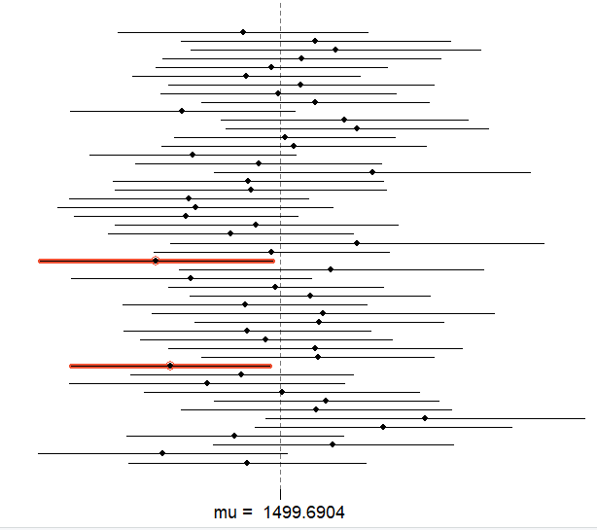

What proportion of your confidence intervals include the true population mean? Is this proportion exactly equal to the confidence level? If not, explain why

|  |
| --- |
| There are two not including true population mean.  P = 1 – (2/50) = 0.96  50 confidence intervals of size 60, but 3 of them don’t include the true population mean, mu = 1499.6904, about 96%, while confidence level is 95%. |

1. Pick a confidence level of your choosing, provided it is not 95%. What is the appropriate critical value?

|  |
| --- |
| Pick confidence level 92%  l <- 1 - 0.08/2  z <- qnorm(l) |

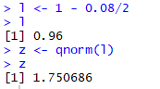

1. Calculate 50 confidence intervals at the confidence level you chose in the previous question. You do not need to obtain new samples, simply calculate new intervals based on the sample means and standard deviations you have already collected. Using the plot_ci function, plot all intervals and calculate the proportion of intervals that include the true population mean.

|  |
| --- |
| l <- 1 - 0.08/2  z <- qnorm(l)  lower_vector <- samp_mean - z * samp_sd / sqrt(n)  upper_vector <- samp_mean + z * samp_sd / sqrt(n)  c(lower_vector[1], upper_vector[1])  plot_ci(lower_vector, upper_vector, mean(population)) |

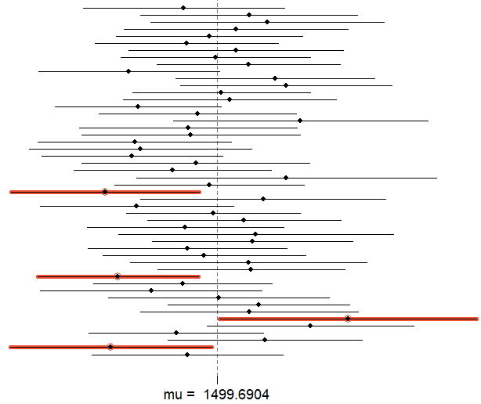

How does this percentage compare to the confidence level selected for the intervals?

|  |
| --- |
| P = 1 – 4/50 = 0.92  So proportion of CI Plot at 92% is 0.92 |